5.11 Using Fig. 5.50, design a problem to help other students to better understand how ideal op amps work.

Although there are many ways to work this problem, this is an example based on the same kind of problem asked in the third edition.

Problem

Find v_{o} and i_{o} in the circuit in Fig. 5.50.

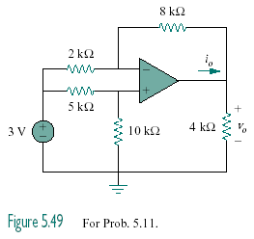
Figure 5.50 for Prob. 5.11

Solution
i_{o}
−
+
10 kΩ
+
v_{o}
−
4 kΩ
2 kΩ
5 kΩ
3 V

+
−
8 kΩ
a
b

v_{b} = 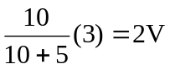

At node a,

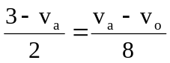 12 = 5v_{a} – v_{o}

But v_{a} = v_{b} = 2V,

12 = 10 – v_{o} v_{o} = –2V

–i_{o} = 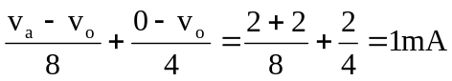

i _{o} = –1mA

